- Prepare DFD and ER diagram of your system.

What is Data Flow Diagram (DFD)?
DFD is the abbreviation for Data Flow Diagram. The flow of data in a system or process is represented by a Data Flow Diagram (DFD). It also gives insight into the inputs and outputs of each entity and the process itself. Data Flow Diagram (DFD) does not have a control flow and no loops or decision rules are present. Specific operations, depending on the type of data, can be explained by a flowchart. It is a graphical tool, useful for communicating with users, managers and other personnel. it is useful for analyzing existing as well as proposed systems.
It should be pointed out that a DFD is not a flowchart. In drawing the DFD, the designer has to specify the major transforms in the path of the data flowing from the input to the output. DFDs can be hierarchically organized, which helps in progressively partitioning and analyzing large systems.
It provides an overview of
- What data is system processes.
- What transformation are performed.
- What data are stored.
- What results are produced , etc.

Types of Data Flow Diagram (DFD)
There are two types of Data Flow Diagram (DFD)
- Logical Data Flow Diagram
- Physical Data Flow Diagram

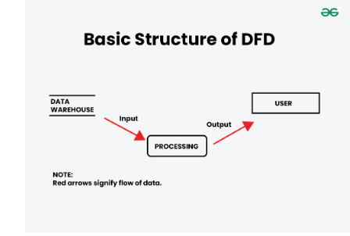

0-level DFD
It is also known as a context diagram. It’s designed to be an abstraction view, showing the system as a single process with its relationship to external entities. It represents the entire system as a single bubble with input and output data indicated by incoming/outgoing arrows.

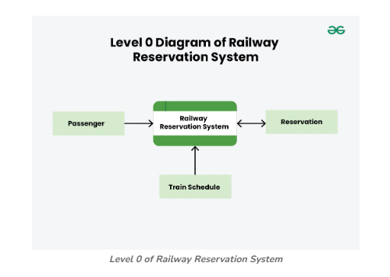
DFD 0 level 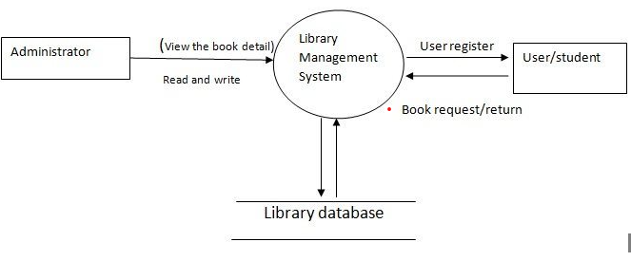

2. Prepare E R diagram for a given project

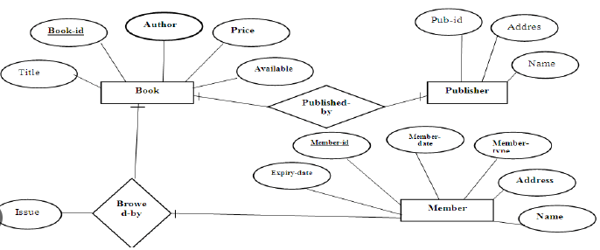 Example of Library management system

